**Add a web part**

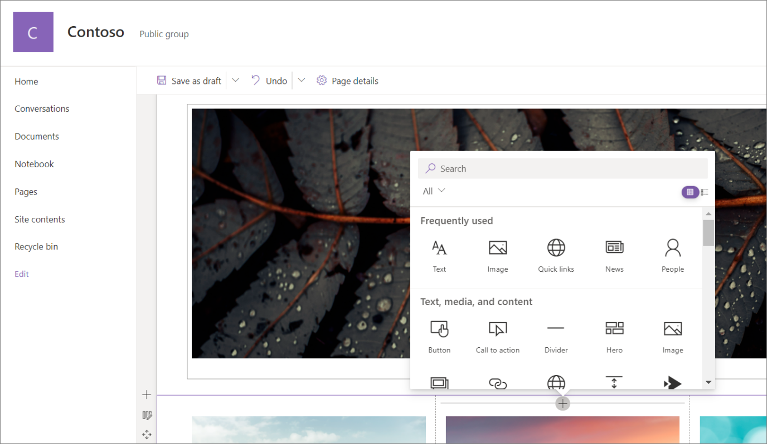

1. Go to the [page](https://support.microsoft.com/en-us/office/create-and-use-modern-pages-on-a-sharepoint-site-b3d46deb-27a6-4b1e-87b8-df851e503dec) where you want to add a web part.
2. If you do not see the site page that you want, click **Site contents** on the Quick Launch bar, in the list of contents, click **Site Pages**, and then click the page that you want.
3. If the page is not already in edit mode, click **Edit** at the top right of the page.
4. Hover your mouse above or below an existing web part and you'll see a line with a circled **+**, like this:

Plus sign for adding web parts to a page

1. Click **+** and you'll see a list of web parts to choose from. To easily find the web part you're looking for, start typing in the **Search** box.

1. Click    for a list view or    for a grid view. You can also sort the web parts and filter them by category from the drop-down list.

**Move or remove a web part**

1. If you're page is not already in edit mode, click **Edit** at the top right of the page.
2. Select the web part you want to move or remove, and you'll see a small toolbar on the left of the web part.

To move the web part, select the **Move web part** button Move web part button and drag the web part where you want it on your page.

To remove the web part, select the **Delete web part** button Delete web part icon. You can also select DEL on the keyboard to delete.

**Available web parts**

Following is a list of a web parts you can use on a page, along with links to more information for each web part.

Divider

The [Divider web part](https://support.microsoft.com/en-us/office/add-a-line-between-web-parts-with-the-divider-web-part-7204a0fa-f0c2-4f1e-8e7b-d0ebd4276ad4) inserts a line between other web parts to help break up your page and make it easier to read.

Document library

The [Document Library web part](https://support.microsoft.com/en-us/office/use-the-document-library-web-part-a9dfecc3-2050-4528-9f00-2c5afc5731b0) displays a document library and customize it with your own title, view, and even size. Users with appropriate permissions can view or edit files directly from the web part, or can go to the full document library by clicking **See all**.

Embed

The [Embed web part](https://support.microsoft.com/en-us/office/add-content-to-your-page-using-the-embed-web-part-721f3b2f-437f-45ef-ac4e-df29dba74de8) displays content on your page from other sites like YouTube videos. Depending on the site, you can either use the site's address or embed code that the site provides.

Events

The [Events web part](https://support.microsoft.com/en-us/office/use-the-events-web-part-5fe4da93-5fa9-4695-b1ee-b0ae4c981909) allows you to add and display upcoming events on your page. You can even include a map with location, online meeting information, and more.

File viewer

The [File viewer web part](https://support.microsoft.com/en-us/office/use-the-file-and-media-web-part-e53a9602-e7b3-4fff-9126-de2f18d1900c) insert a files on your page. File types you can insert include Excel, Word, PowerPoint, Visio, .PDFs, 3D Models, videos, and more.

**Note:**Note: In SharePoint 2019, file types that can be inserted are limited to Word, Excel, and PowerPoint (specifically .doc, .docx,. xls, .xlsx, .pot, .potx, .ppt and .pptx).

Hero

The [Hero web part](https://support.microsoft.com/en-us/office/use-the-hero-web-part-d57f449b-19a0-4b0d-8ce3-be5866430645) is a great way to bring focus and visual interest to your page. You can display up to five items in the Hero web part and use compelling images, text, and links to draw attention to each. The Hero web part is included by default on Communication sites, but you can also add the Hero web part to other pages.

Highlighted content

The [Highlighted content web part](https://support.microsoft.com/en-us/office/use-the-highlighted-content-web-part-e34199b0-ff1a-47fb-8f4d-dbcaed329efd) dynamically displays content based on content type (documents, pages, news, videos, images, etc), filtering, or a search string. You can also set the scope of the search to a site or site collection, and sort the results.

Image

The [Image web part on a page](https://support.microsoft.com/en-us/office/use-the-image-web-part-a63b335b-ad0a-4954-a65d-33c6af68beb2) inserts an image on the page, either from your site, your OneDrive, or your hard drive.

Image gallery

The [Image Gallery web part](https://support.microsoft.com/en-us/office/use-the-image-gallery-web-part-bbcbe560-14a7-4369-8ef5-3255845e3bfd) shares collections of pictures on a page. Simply select your images with the file picker or drag them onto the web part. Once you’ve created your collection, you can drag and drop the images to reorder them as needed.

List

The [List web part](https://support.microsoft.com/en-us/office/use-the-list-web-part-ef0a1b80-f8b3-443d-b04a-1e76c70b5537) displays a list that you can customize with your own title, view, and even size. Users can view the list, or go to the full list by clicking **See all**.

My feed

The [My feed web part](https://support.microsoft.com/en-us/office/use-the-my-feed-web-part-d5c79a85-0596-4602-975a-9c06824b09c7) shows a mix of content from across Microsoft 365, based on what's likely to be most relevant to the current user at any given time.

News

The [News web part](https://support.microsoft.com/en-us/office/use-the-news-web-part-on-a-sharepoint-page-c2dcee50-f5d7-434b-8cb9-a7feefd9f165) keeps your team in the loop as well as engages them with important or interesting stories. You can quickly create eye-catching posts like announcements, people news, status updates, and more that can include graphics and rich formatting.

Organization chart

Use this web part to show a visual [organization chart](https://support.microsoft.com/en-us/office/use-the-organization-chart-web-part-77e3fd2e-568c-454c-a0b4-611eb79fce11) by choosing a person to build the chart around. You can specify how many reporting levels up you want to show.

People

The [People web part](https://support.microsoft.com/en-us/office/show-people-profiles-on-your-page-with-the-people-web-part-7e52c5f6-2d72-48fa-a9d3-d2750765fa05) displays a selected group of people and their profiles on your page. It can be used for contact information, team information, presenters, and more.

Quick chart

The [Quick Chart web part](https://support.microsoft.com/en-us/office/use-the-quick-chart-web-part-bcfee244-2408-400b-a9bd-4eca61aead51) adds simple charts to your page. Enter your data points, add labels, pick your chart type -- column or pie -- and publish.

Quick links

The [Quick Links web part](https://support.microsoft.com/en-us/office/use-the-quick-links-web-part-e1df7561-209d-4362-96d4-469f85ab2a82) "pins" items to your page for easy access.

Site activity

The [Site Activity web part](https://support.microsoft.com/en-us/office/use-the-site-activity-web-part-1fa91401-ac36-42b6-beba-bb8469d6cbfa) automatically shows recent activity on your site, such as files uploaded, edits made, lists and libraries created, and so on. Just add the web part, and the latest activity is pulled in automatically.

Spacer

The [Spacer web part](https://support.microsoft.com/en-us/office/add-vertical-space-to-a-page-with-the-spacer-web-part-7e6ae288-1634-44e2-bc4c-7fb4042ee905) allows you to control vertical space on your page.

Stream (classic)

The [Stream (classic) web part](https://support.microsoft.com/en-us/office/use-the-stream-classic-web-part-b97fa87c-1337-4271-a059-17f0d2b26e8b) displays a video right on your page from your organization's Microsoft Stream (classic) video portal.

Text

The [Text web part](https://support.microsoft.com/en-us/office/add-text-tables-and-images-to-your-page-with-the-text-web-part-729c0aa1-bc0d-41e3-9cde-c60533f2c801) adds paragraphs and tables to your page. Formatting options like styles, bullets, indentations, highlighting, and links are available.

Weather

The [Weather web part](https://support.microsoft.com/en-us/office/show-the-weather-on-your-page-4a86540e-0846-4fc0-bad0-1a82fcd430fc) shows the current weather on your page.

**Note:**The Weather web part is not available in SharePoint Server 2019.

Yammer

The [Yammer web part](https://support.microsoft.com/en-us/office/use-a-viva-engage-web-part-in-sharepoint-online-a53cfa0c-3d09-42c8-a286-1038a81c59da) enhances collaboration by embedding Yammer conversations on your page, if your organization has an active Yammer network (for example: [www.yammer.com/contoso.com](http://www.yammer.com/contoso.com)).

**Web part maintenance mode**

Having trouble with web parts you've put on a page? Try using [using web part maintenance mode](https://support.microsoft.com/en-us/office/open-and-use-the-web-part-maintenance-page-eff9ce22-d04a-44dd-ae83-ac29a5e396c2) to help troubleshoot the issue.

Open and use the web part maintenance page

If you suspect a web part is causing problems on your SharePoint page, you can open the web part maintenance page to help isolate and fix issues. You must have edit permissions to use the page.

The web part maintenance page in SharePoint Online or SharePoint Server 2019 is actually a "maintenance mode." While in maintenance mode, you can:

* View and copy the data and manifest information for each web part.
* Remove web parts you suspect are causing problems.
* Rearrange web parts.

**Note:**You cannot edit web parts in maintenance mode.

Maintenance mode initially opens in a view-only state, but if you have edit permissions, you can remove and rearrange web parts.

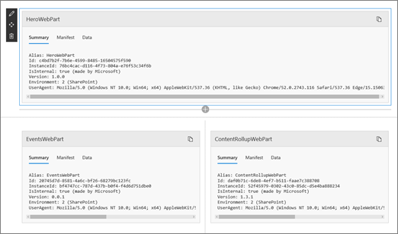

**Open web part maintenance mode**

1. Go to the page for which you want to open web part maintenance mode.
2. In the address line of your browser, append **?maintenancemode=true** to the end of the URL for the page. For example:

https://contoso.sharepoint.com/teams/SitePages/Home.aspx?maintenancemode=true

On your page, you will see a summary of data from the Manifest and Data tabs. The summary information includes:

|  |  |
| --- | --- |
| Alias | The name of the web part |
| Id | The unique ID of the web part |
| Instance Id | The ID of a specific instance of a web part (that is, if you have two more of the same web parts on a page, they will each have the same web part ID, but a different instance ID. |
| IsInternal | Indicates whether the web part was made by Microsoft or a third party. If True, it is made by Microsoft. If False, it is made by a third party. |
| Version | The version number of the web part. |
| Environment | **Environment**: Indicates the SharePoint environment in use.   * 0 = Test environment * 1 = Local Workbench * 2 = SharePoint * 3 = Classic SharePoint |
| UserAgent | A string that contains information about the device and software in use (such as browser type and version). |

**Copy data**

1. Go to the web part for which you want to copy data.
2. Click **Copy data**.

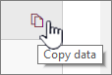

1. Paste the data into a text editor or a tool you use for web part development.

**Note:**It is not yet possible to directly edit data or manifest information in web part maintenance mode.

**Delete or move web parts**

1. Once you are in maintenance mode, click **Edit** at the top right of the page.

Do one of the following:

* + Click **Delete** Delete web part icon to remove a web part.
  + Click **Move** Move web part button and then drag the item where you want.

**Save, Discard, or Publish changes**

* Click **Discard changes** to undo any changes you made.

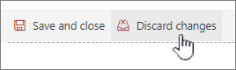

* Click **Save and close** to save your changes.

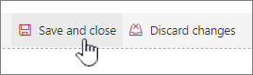

* Click **Publish** to publish your changes.

Click Publish when you're ready to show your changes

**Leave maintenance mode**

Remove **?maintenancemode=true** from the URL and refresh the page.